Project Design Phase-II
Data Flow Diagram & User Stories

Date | 20 February 2026
Team ID | LTVIP2026TMIDS66369
Project Name | calculating family expenses using service now
Maximum Marks | 4 Marks

Data Flow Diagrams:
A Data Flow Diagram (DFD) is a traditional visual representation of the information flows within a system. A neat and clear DFD can depict the right amount of the system requirement graphically. It shows how data enters and leaves the system, what changes the information, and where data is stored.
Example: (Simplified)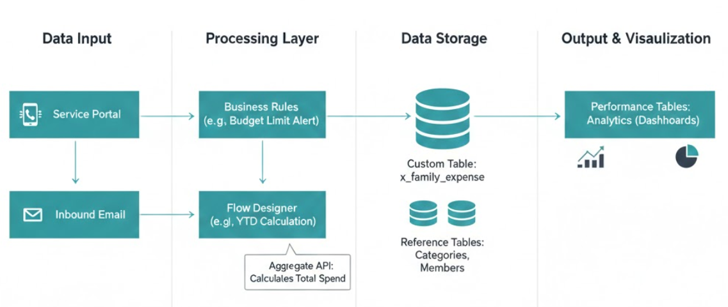

User Stories
Use the below template to list all the user stories for the product.
Field Name | Field Type | Description | Example Data
Category | Choice/Dropdown | The type of expense | Housing, Groceries, Utilities
Description | String | Short detail of the purchase | Weekly grocery run at Costco
Amount | Currency | The cost of the item | $150.00
Date | Date | When the expense occurred | 2026-02-16
Paid By | Reference (User) | Which family member paid | John Doe
Payment Method | Choice | How it was paid | Credit Card, Cash, Debit
Status | Choice | Track if it's cleared | Pending, Paid, Recurring

